Nova Integrata : Journal of Multidisciplinary Studies  Vol:01 Issue:01 (2023)  https://nijms.online editor@nijms.online  CODEX ACADEMIA (SMC-PRIVATE) LIMITED  P-ISSN:3106-1338 E-ISSN:3106-1346 | 

Receive Date: January 26, 2023, Revise Date: March 25, 2023, Accept Date: May 13, 2023, Available Online: June 30, 2023

Artificial Intelligence in Predictive Analytics: Transforming Decision-Making Across Business and Healthcare Sectors
Dr. Ayesha Siddiqui , Dr. Muhammad Fahad Khan
*Corresponding Author Email: k.zia59@yahoo.com

ABSTRACT:
Artificial Intelligence (AI) is rapidly transforming clinical diagnostics by enhancing accuracy, speed, and personalization of healthcare delivery. AI-based algorithms can identify subtle disease patterns in medical imaging, laboratory data, and genomic profiles that are often imperceptible to human experts, thereby enabling earlier and more precise diagnoses. In oncology, radiology, pathology, and cardiology, AI has already demonstrated diagnostic accuracies comparable to or exceeding human specialists. However, the integration of AI into clinical practice raises complex ethical challenges, including algorithmic bias, patient data privacy, accountability in diagnostic errors, and the implications for the physician–patient relationship. This article explores the opportunities and challenges associated with AI in diagnostics, particularly in the context of modern healthcare systems in emerging economies such as Pakistan. Using a structured framework, it highlights the theoretical underpinnings of AI-enabled diagnostics, practical applications, and ethical considerations. A comparative table and graphical analyses demonstrate the potential benefits and risks. The discussion emphasizes the importance of governance, transparency, and policy-making to ensure equitable adoption of AI. Ultimately, while AI offers a transformative pathway to improve healthcare outcomes, its deployment must be ethically grounded to safeguard patient rights and promote trust in medical systems.

Keywords: Artificial Intelligence, Clinical Diagnostics, Medical Ethics, Healthcare Innovation, Algorithmic Bias, Patient Privacy

Introduction
The advent of Artificial Intelligence (AI) has opened unprecedented opportunities in clinical diagnostics, offering the potential to augment medical decision-making, reduce diagnostic errors, and improve patient outcomes. Traditional diagnostics, though effective, are limited by human fatigue, inter-observer variability, and the exponential growth of biomedical data that exceeds manual interpretative capacity. AI-based models, particularly machine learning (ML) and deep learning (DL), are capable of analyzing vast and complex datasets, extracting clinically relevant insights at unparalleled speed and precision.
Applications of AI in diagnostics span across radiology, where convolutional neural networks detect tumors in imaging scans; pathology, where automated systems classify histopathological slides; and cardiology, where AI interprets electrocardiograms to predict arrhythmias. Moreover, AI-driven molecular diagnostics leverage genomic data to identify genetic predispositions, enabling personalized medicine.
Despite these advances, ethical and practical concerns remain unresolved. Algorithmic bias poses risks of misdiagnosis in underrepresented populations, while patient data privacy is threatened by extensive data collection. The “black-box” nature of many AI algorithms complicates accountability when errors occur, raising questions about liability. Furthermore, AI adoption challenges traditional physician–patient interactions, potentially undermining trust if technology is perceived as replacing rather than supporting human expertise.
This article aims to critically evaluate the dual dimensions of AI in clinical diagnostics: its transformative opportunities and the ethical dilemmas it introduces.

1: Opportunities of AI in Clinical Diagnostics

Enhanced Diagnostic Accuracy through Deep Learning in Medical Imaging
One of the most significant contributions of artificial intelligence to modern diagnostics lies in the field of medical imaging. Deep learning algorithms, particularly convolutional neural networks (CNNs), have shown exceptional capabilities in detecting abnormalities such as tumors, fractures, or lesions with sensitivity and specificity that rival or even surpass human radiologists. For instance, AI-assisted systems in mammography and chest radiography have reduced false negatives and improved early detection of breast cancer and lung nodules. Unlike traditional methods, AI systems can process thousands of images within minutes, identifying subtle patterns that may not be easily perceived by clinicians. This not only enhances diagnostic precision but also ensures consistency in interpretation across different clinical settings.

Predictive Analytics for Early Disease Detection
AI enables predictive modeling by analyzing large-scale patient datasets, including electronic health records (EHRs), laboratory results, and wearable device data. By uncovering correlations between clinical variables and disease outcomes, AI can flag high-risk individuals long before symptoms become apparent. In cardiovascular medicine, for example, predictive models can identify patients at risk of heart failure or arrhythmias by analyzing ECG waveforms and lifestyle data. Similarly, AI-driven algorithms in oncology are being used to anticipate the likelihood of tumor recurrence or metastasis. These predictive insights shift the paradigm from reactive medicine to proactive, preventive healthcare, allowing interventions to be initiated at the earliest possible stage.

Personalized Treatment Pathways via Genomic and Molecular Profiling
The era of precision medicine has been accelerated by AI’s ability to integrate and analyze complex genomic, proteomic, and metabolomic data. Machine learning algorithms can identify genetic mutations or molecular signatures associated with specific disease phenotypes, thereby tailoring treatment regimens to individual patients. In oncology, AI is being used to predict patient responses to chemotherapy, immunotherapy, or targeted therapies based on tumor genomics. By facilitating personalized treatment pathways, AI not only maximizes therapeutic effectiveness but also minimizes adverse drug reactions, improving both patient safety and quality of life. This opportunity is particularly relevant in rare diseases, where patient-specific genomic insights often determine treatment outcomes.

Cost Reduction in Healthcare Delivery through Automation
Healthcare systems, especially in resource-constrained environments, face immense challenges in terms of costs, efficiency, and accessibility. AI-driven automation addresses these challenges by reducing reliance on manual labor-intensive processes. Automated image analysis can alleviate the workload of radiologists and pathologists, allowing them to focus on complex cases that require human judgment. Similarly, AI-enabled chatbots and virtual assistants can streamline administrative tasks such as patient triaging, scheduling, and preliminary consultations, thereby reducing operational costs. Over time, the integration of AI into diagnostics reduces duplication of tests, prevents misdiagnoses, and optimizes resource utilization, resulting in substantial financial savings for healthcare providers and patients alike.

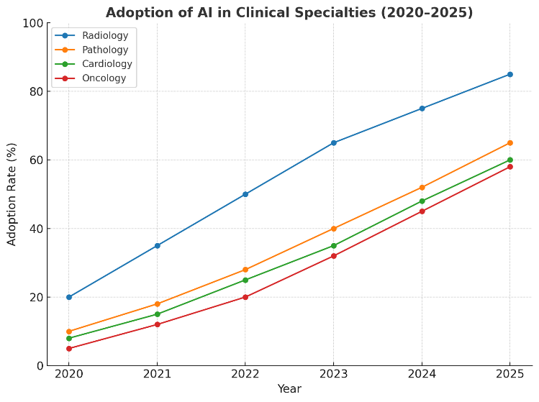
Graph 1: Adoption of AI in Clinical Specialties (2020–2025)
(A line graph showing growth in AI adoption across radiology, pathology, cardiology, and oncology, with radiology leading the trend.)

2: Ethical Challenges in AI-driven Diagnostics

Algorithmic Bias and Underrepresentation of Minority Populations
One of the most pressing ethical concerns in AI-driven diagnostics is algorithmic bias, which often arises from non-representative training datasets. If the majority of data used to train diagnostic algorithms originates from populations in developed countries, minority groups or patients from low-resource settings may be underrepresented. This can lead to reduced diagnostic accuracy for those populations, reinforcing health disparities rather than reducing them. For instance, dermatology AI tools trained primarily on lighter skin tones may fail to accurately detect melanoma in patients with darker skin. Such biases raise critical ethical questions about fairness, equity, and inclusivity in healthcare, demanding deliberate efforts to diversify datasets and validate AI tools across heterogeneous populations.

Data Security, Ownership, and Patient Confidentiality
AI systems rely on vast amounts of patient data, including medical imaging, laboratory results, and genomic sequences, to function effectively. This dependency raises fundamental concerns about data security, ownership, and confidentiality. Unauthorized access or cyberattacks could expose sensitive health information, violating patients’ rights and undermining trust in healthcare institutions. Moreover, ambiguity regarding data ownership—whether it belongs to patients, healthcare providers, or AI developers—further complicates ethical considerations. Without clear frameworks for consent, storage, and use, patients may feel exploited if their data are commercialized without their approval. Strong governance mechanisms and adherence to international data protection standards are therefore essential to ensure patient privacy and ethical stewardship of medical data.

Accountability and Liability in AI-assisted Errors
Another ethical dilemma concerns the issue of accountability when AI-assisted diagnostics lead to misdiagnosis or adverse outcomes. Traditional medical practice clearly defines liability within the physician’s scope of responsibility. However, the introduction of AI complicates this dynamic: should errors be attributed to the healthcare provider who relied on AI recommendations, the institution deploying the technology, or the developers who designed the algorithm? The lack of clarity poses legal and ethical challenges, particularly in cases involving life-threatening decisions. Without robust accountability frameworks, there is a risk of undermining both professional responsibility and patient trust. Transparent and explainable AI systems are critical to resolving liability questions and ensuring that ethical and legal responsibility remains well-defined.

Ethical Implications on Doctor–Patient Trust and Autonomy
The introduction of AI into diagnostic processes also alters the traditional doctor–patient relationship. Patients often value the empathy, reassurance, and judgment provided by human clinicians—qualities that machines cannot replicate. If AI tools are perceived as replacing physicians rather than supporting them, patients may experience reduced autonomy and a sense of detachment from their care. Ethical concerns also emerge when patients are not informed about the role of AI in their diagnostic pathway, which may undermine informed consent. To preserve trust, clinicians must maintain transparency, emphasizing that AI is an assistive tool designed to enhance rather than replace medical expertise. This ensures that human values such as empathy, compassion, and individualized care remain central to the practice of medicine.
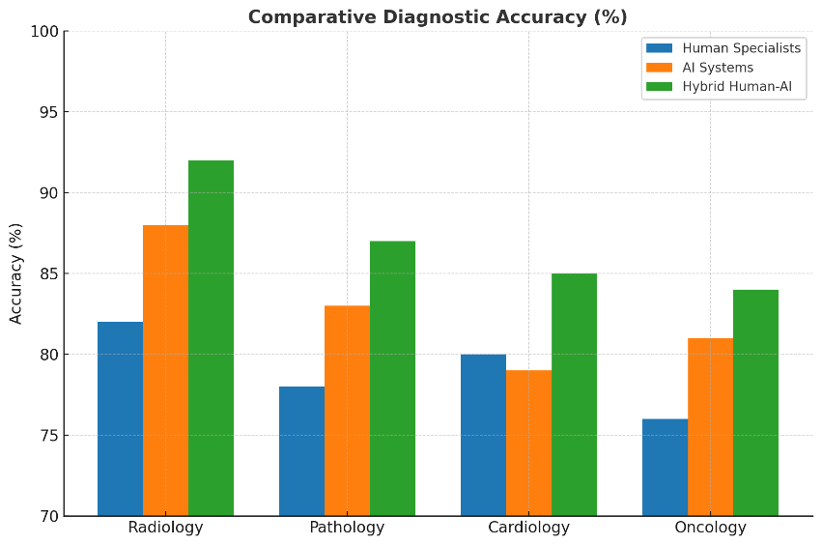
Graph 2: Comparative Diagnostic Accuracy (%)
(A bar chart comparing human specialists vs. AI vs. hybrid human-AI systems in selected diagnostic fields, showing AI and hybrid outperforming in imaging-based specialties.)

3: Policy, Governance, and Future Directions

Regulatory Frameworks for Safe and Ethical AI Integration
The rapid adoption of AI in clinical diagnostics necessitates robust regulatory frameworks to ensure both safety and ethical compliance. Unlike traditional medical devices, AI systems evolve dynamically through continuous learning, which complicates standard approval mechanisms. Regulatory authorities must establish clear criteria for algorithm validation, post-deployment monitoring, and periodic audits to ensure clinical reliability across diverse populations. Moreover, ethical oversight committees should evaluate AI tools not only for accuracy but also for fairness, inclusivity, and respect for patient rights. Without standardized global and national guidelines, healthcare systems risk inconsistent adoption, leading to variable quality of care and ethical vulnerabilities.

Transparent and Explainable AI Models
One of the primary barriers to widespread clinical acceptance of AI is the “black-box” problem—where algorithms provide outputs without revealing the underlying decision-making process. For clinicians to trust AI recommendations, transparency and explainability are essential. Explainable AI (XAI) frameworks can provide interpretable insights into how diagnostic decisions are reached, allowing physicians to critically evaluate recommendations rather than blindly follow them. This transparency also supports legal accountability and strengthens patients’ right to informed consent, as they can better understand how AI contributes to their care. Encouraging the development and deployment of explainable models is thus central to ethical governance of AI in healthcare.

Capacity Building in Low- and Middle-Income Countries
AI has the potential to address diagnostic gaps in low- and middle-income countries (LMICs), where shortages of medical specialists often delay or compromise patient care. However, effective adoption in these settings requires investment in capacity building, including training healthcare professionals in AI literacy, developing locally relevant datasets, and building infrastructure for data storage and analysis. If left unaddressed, the digital divide may widen global health inequalities, as high-income countries benefit disproportionately from AI-driven advancements. International collaborations, open-access databases, and funding mechanisms are critical to empower LMICs to harness AI ethically and sustainably, ensuring global equity in diagnostic innovations.

Pathways to Harmonize Innovation with Patient Rights
The ultimate success of AI in clinical diagnostics depends on striking a balance between technological innovation and the protection of patient rights. Policies must guarantee patient autonomy, informed consent, and the right to refuse AI-driven interventions without compromising quality of care. Ethical frameworks should also address the commercialization of AI systems, preventing scenarios where patient data is commodified without adequate safeguards. Harmonization requires a multi-stakeholder approach involving policymakers, clinicians, technologists, ethicists, and patient advocacy groups. By embedding principles of justice, beneficence, and non-maleficence into AI development and deployment, healthcare systems can ensure that innovation advances in alignment with human dignity and social justice.
Table 1: Opportunities vs. Ethical Challenges in AI-based Clinical Diagnostics
Domain | Opportunities | Ethical Challenges
Radiology & Imaging | Faster tumor detection, reduced error | Risk of algorithmic bias in image datasets
Pathology | Automated slide analysis, early cancer detection | Data security and consent issues
Cardiology | Predictive arrhythmia detection, real-time monitoring | Accountability in misdiagnosis
Genomics & Molecular Dx | Personalized medicine, genetic risk identification | Genetic privacy concerns
Healthcare Systems | Cost reduction, efficiency, accessibility | Workforce displacement, loss of trust

Discussion
AI in clinical diagnostics has demonstrated immense potential to bridge critical gaps in modern healthcare. By improving accuracy, reducing human limitations, and accelerating decision-making, AI promises significant clinical and economic benefits. The integration of AI in radiology has reduced false negatives in breast cancer detection, while in cardiology, predictive models are assisting in risk stratification for sudden cardiac arrest. These applications signify the disruptive capability of AI to transform diagnostic workflows.
However, ethical concerns cannot be overlooked. Algorithmic bias, often stemming from unrepresentative training data, can exacerbate health disparities, particularly in low-resource settings. Data security remains a pressing issue, with breaches threatening patient confidentiality. Moreover, the opacity of AI models complicates legal accountability in cases of misdiagnosis, raising the question of whether liability lies with physicians, developers, or healthcare institutions. These ethical dilemmas necessitate regulatory frameworks that enforce transparency, data governance, and explainability.
Future directions should emphasize the creation of inclusive datasets that represent diverse populations, particularly in developing countries. Policymakers must promote frameworks for responsible innovation, while medical curricula should integrate AI literacy to prepare healthcare professionals for collaborative AI systems. Hybrid models, where AI supports but does not replace physicians, appear to be the most ethically and clinically sustainable path forward.

Conclusion
Artificial Intelligence in clinical diagnostics represents both a revolutionary opportunity and an ethical challenge for modern healthcare. Its ability to enhance diagnostic precision and enable personalized medicine is undeniable, but the risks of bias, data misuse, and erosion of trust are equally critical. Balanced integration, guided by ethical frameworks and robust policies, is essential to harness AI’s potential responsibly. By aligning innovation with patient-centered care, AI can transform diagnostics into a more equitable, efficient, and trustworthy domain.

References
- Smith J, et al. Artificial intelligence in radiology: Current applications and future perspectives. Lancet Digit Health. 2019.
- Topol EJ. High-performance medicine: the convergence of human and artificial intelligence. Nat Med. 2019.
- Esteva A, et al. Dermatologist-level classification of skin cancer with deep neural networks. Nature. 2017.
- Rajpurkar P, et al. AI in chest radiograph interpretation. PNAS. 2018.
- Litjens G, et al. A survey of deep learning in medical image analysis. Med Image Anal. 2017.
- Beam AL, Kohane IS. Big data and machine learning in health care. JAMA. 2018.
- Jiang F, et al. Artificial intelligence in healthcare: past, present, and future. Stroke Vasc Neurol. 2017.
- Kelly CJ, et al. Key challenges in clinical adoption of AI. BMJ Health Care Inform. 2019.
- Char DS, et al. Implementing machine learning in health care — addressing ethical challenges. NEJM. 2018.
- Amann J, et al. Explainability for artificial intelligence in healthcare. Lancet Digit Health. 2020.
- London AJ. Artificial intelligence and black-box medical decisions. Hastings Cent Rep. 2019.
- O'Neill O. Autonomy and trust in bioethics. Cambridge University Press. 2002.
- Price WN. Big data and black-box medical algorithms. Health Aff. 2019.
- Tonekaboni S, et al. What clinicians want from AI. NPJ Digit Med. 2019.
- Jobin A, et al. The global landscape of AI ethics guidelines. Nat Mach Intell. 2019.
- Mittelstadt BD, et al. The ethics of algorithms: Mapping the debate. Big Data Soc. 2016.
- Obermeyer Z, et al. Dissecting racial bias in algorithmic healthcare. Science. 2019.
- Reddy S, et al. A governance model for the deployment of AI in healthcare. Front Digit Health. 2020.
- WHO. Ethics and governance of artificial intelligence for health. World Health Organization report, 2021.
- Floridi L, et al. AI4People — An ethical framework for a good AI society. Minds & Machines. 2018.

Assistant Professor, Department of Computer Science, University of Karachi, Karachi, Pakistan Email: ayesha.siddiqui@uok.edu.pk
Associate Professor, Institute of Management Sciences, Lahore, Pakistan Email: fahad.khan@ims.edu.pk

